**INDEX**

| **Sr.no** | **Title** | **Date** |
| --- | --- | --- |
| 1. | Objective | 26/01/2024 |
| 2. | Scope | 28/01/2024 |
| 3. | Testing Methodology | 13/02/2024 |
| 4. | Approach | 19/02/2024 |
| 5. | Assumptions | 04/03/2024 |
| 6. | Risk | 19/03/2024 |
| 7. | Backup Plan/ Mitigation Plan | 28/03/2024 |
| 8. | Roles and Responsibilities | 29/03/2024 |
| 9. | Scheduling | 01/04/2024 |
| 10. | Defect Tracking | 04/04/2024 |
| 11. | Test Environment | 06/04/2024 |
| 12. | Entry & Exit Criteria | 09/04/2024 |
| 13. | Test Automation | 13/04/2024 |
| 14. | Deliverables | 13/04/2024 |
| 15. | Templates | 18/04/2024 |

1. **Objective**

* Main objective to write a test plan is to ensure testing activities are on track according to plan and schedule.
* Document will give brief of each testing phase that will be carried out by QA person [i.e, Viraj D. Utekar] to ensure the quality is met to requirement standards.

1. **Scope**

**2.1 Feature to be tested**:

* User Authentication - [Signup, login, logout]
* Landing page with categories and New Arrivals.
* Product Listing Page
* Sort and filter products
  + Sort by Price Low to High and High to Low
  + Filter using Minimum and Maximum Price Range
  + Filter by Book Genre Categories
  + Filter by average product rating
  + Filter to include/exclude out of stock products
  + Filter products as per fast delivery availability
  + Clear all filters
* Wishlist Management
  + Add / remove from the wishlist
  + Add items to cart
* Cart Management
  + Add to cart
  + Change items quantity in cart
  + Remove from cart
  + Add to wishlist from cart
  + Apply Coupon
* Single Product Page
* Order Summary of the ordered items
* Custom Toast Component with 4 types - Success, Error, Warning and Information
* Razorpay payment Integration
* Orders page
* Search bar to search books by Book name and Author name
* Pagination.

**2.2 Feature not to be tested:**

* Login Form - Forgot password Link
* Footer Links - About and Help Section
* Note: Payment module is third party integration which is not feasible to test

1. **Testing Methodology**

| **sr.no** | **Feature** | **Component Testing** | **Integration Testing** | **System Testing** |
| --- | --- | --- | --- | --- |
|  | Sign Up Form | Yes | Yes | Yes |
|  | Sign In Form | Yes | Yes | Yes |
|  | Logout | - | Yes | Yes |
|  | Navigation Menu Links |  | Yes | Yes |
|  | Footer Menu Links  [Only Social Section] | - | Yes | Yes |
|  | Landing page with  Genres and New Arrival |  | Yes | Yes |
|  | Product Listing page | Yes | Yes | Yes |
|  | Sort and Filter products | Yes | Yes | Yes |
|  | Wishlist Management | Yes | Yes | Yes |
|  | Cart Management | Yes | Yes | Yes |
|  | Single Product Page | - | Yes | Yes |
|  | Order Summary of ordered Items | Yes | Yes | Yes |
|  | Custom Toaster Message | - | Yes | Yes |
| 14. | Search bar on Product Listing Page | Yes | Yes | Yes |
| 15. | Pagination | - | Yes | Yes |

**4. Approach**

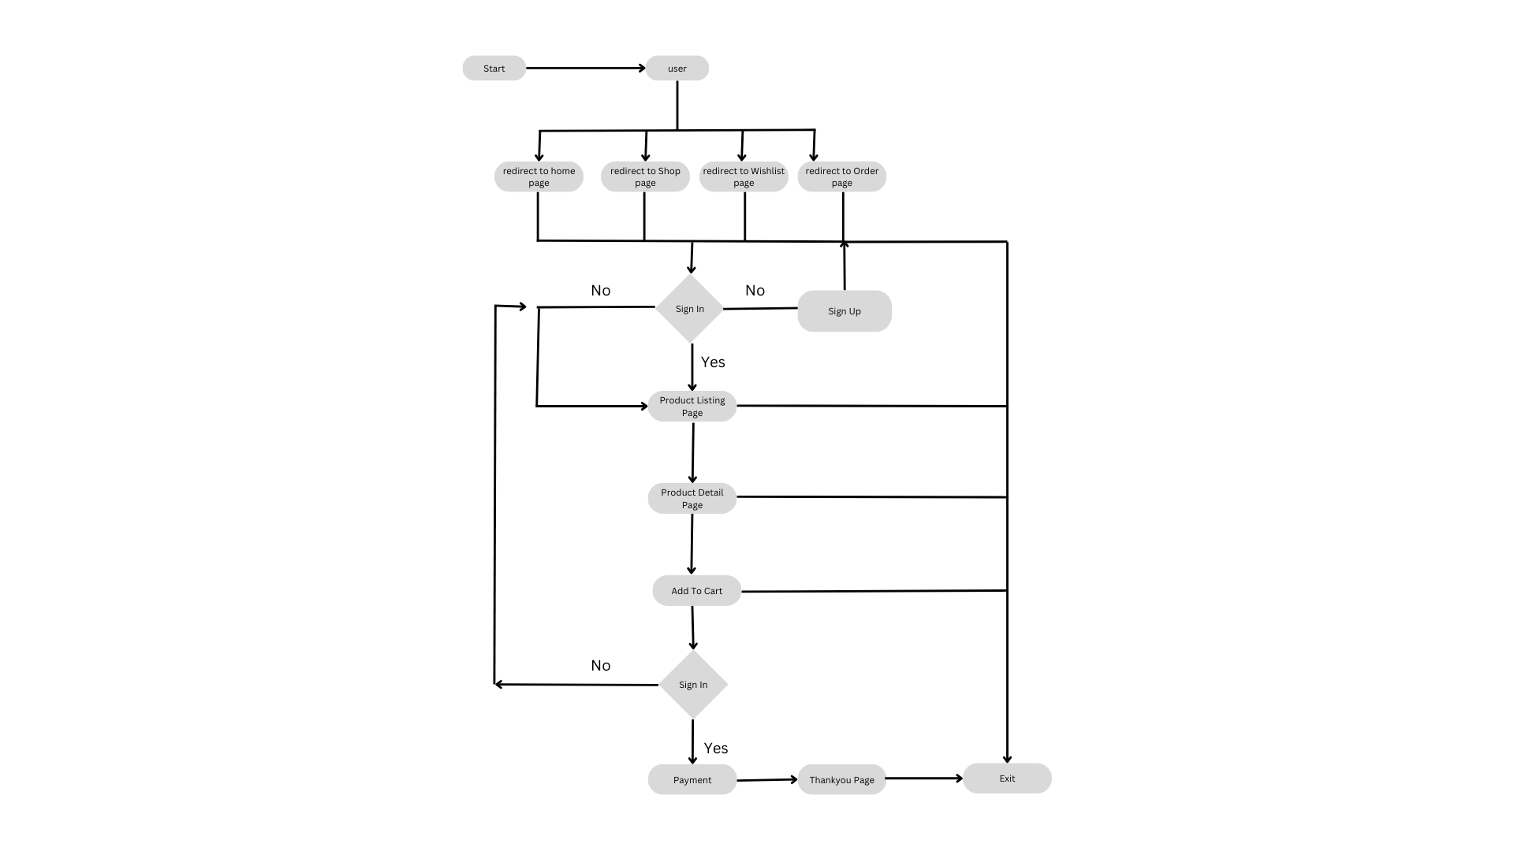

**5. Assumptions**

* There are no such assumptions for now.

**6. Risk**

* found no such risk for this project.

**7. Backup Plan / Mitigation Plan**

* There is no backup plan for now.

**8. Roles and Responsibilities**

| **Sr.no** | **Role & Responsibility** | **Name** |
| --- | --- | --- |
| 1. | Test Planning, Approving Test Cases | Viraj D. Utekar |
| 2. | Test Strategy Implementation | Viraj D. Utekar |
| 3. | Creation of Test Scenarios | Viraj D. Utekar |
| 4. | Creation of Test Case | Viraj D. Utekar |
| 5. | Test Environment Setup | Viraj D. Utekar |
| 6. | Test Case Execution, Defect Tracking | Viraj D. Utekar |

**9. Scheduling**

| **Sr.no** | **Task** | **Start date** | **End date** |
| --- | --- | --- | --- |
| 1**.** | Preparation of Test Plan Document | 18-03-2024 | 22-03-2024 |
| 2. | Preparation of Test Scenario Document | 23-03-2024 | 24-03-2024 |
| 3 | Reviewing Test Scenario | 25-03-2024 | 25-03-2024 |
| 3. | Preparation of Test Case Document | 26-03-2024 | 29-03-2024 |
| 4. | Reviewing Test Case | 30-03-2024 | 30-03-2024 |
| 5. | Executing Test Cases | 1-03-2024 | 02-04-2024 |
| 6. | Integration Testing | 03-04-2024 | 05-04-2024 |

**10. Defect Tracking**

NA

**11. Test Environment**

- Steps to set up and run project in local environment:

1. Install Visual Studio Editor
2. Create an new account on GIT
3. Create folder on local environment
4. Install and Run Git Scm
5. Locate to create folder through git scm
6. Redirect to [Project link](https://github.com/Naman-Saxena1/Bookztron-E-Commerce_Book_Store)
7. Clone project into created folder on local environment

Command: git clone [project url]

1. Open project into visual studio editor
2. Ensure you are in project workspace where package.json file is located
3. Install all dependencies

Command: npm install

1. Run the project

Command: npm run start

- Device, Browser and version it can be tested on

| **Sr.no** | **Device Type** | **Browser** | **Version** |
| --- | --- | --- | --- |
|  | Desktop | Chrome | 123 |
| Firefox | 124 |
| Microsoft Edge | 123 |

**12. Entry Exit Criteria**

| **Sr.no** | **Module** | **Entry criteria** | **Exit criteria** |
| --- | --- | --- | --- |
| 1. | Footer | 100% test case should be passed | No test cases should be failed |
| 2. | Header | 100% test case should be passed | No test cases should be failed |
| 3. | Home | 100% test cases should be passed | No test cases should be failed |
| 4. | Signup | 98% test cases should be passed | Not more than 2% test cases should be failed |
| 5. | Sign In | 98% test cases should be passed | Not more than 2% test cases should be failed |
| 6. | Shop | 99% test cases should be passed | Not more than 1% test cases should be failed |
| 7. | Product Detail Page | 100% test cases should be passed | No test cases should be failed |
| 8. | Wishlist | 100% test cases should be passed | No test cases should be failed |
| 9. | Cart | 100% test cases should be passed | No test cases should be failed |

**13. Test Automation**

* For current release, no automation testing is needed

**14. Test Deliverables**

| **Sr.no** | **Document Title** | **Url** |
| --- | --- | --- |
| 1 | Project Overview | [Link-1](https://docs.google.com/document/d/1SC4Wm9dmtbm06NjSp1FT_xnLsSf0PplvlihGYTKC9eI/edit) |
| 2. | Requirement Traceability Matrix | [Link-2](https://docs.google.com/spreadsheets/d/1Xn1pI4N63VeXSZr5JFgsBAQ4lMceq8Zz6SQhuh9-XBg/edit#gid=0) |
| 3. | Test Scenarios | [Link-3](https://docs.google.com/spreadsheets/d/1TYSYHMAbDgj0MgPVuoYIeI2Hfa_xM9Tx_11x4FXr8-c/edit#gid=0) |
| 4. | Test Cases | [Link-4](https://docs.google.com/spreadsheets/d/1G83w-LxpaW8D_jGywx3S0pSeOMNO_ELWXK7Jz7PQnU0/edit#gid=1692088981) |

**15. Templates**

For UI, Functional Testing Template Format:

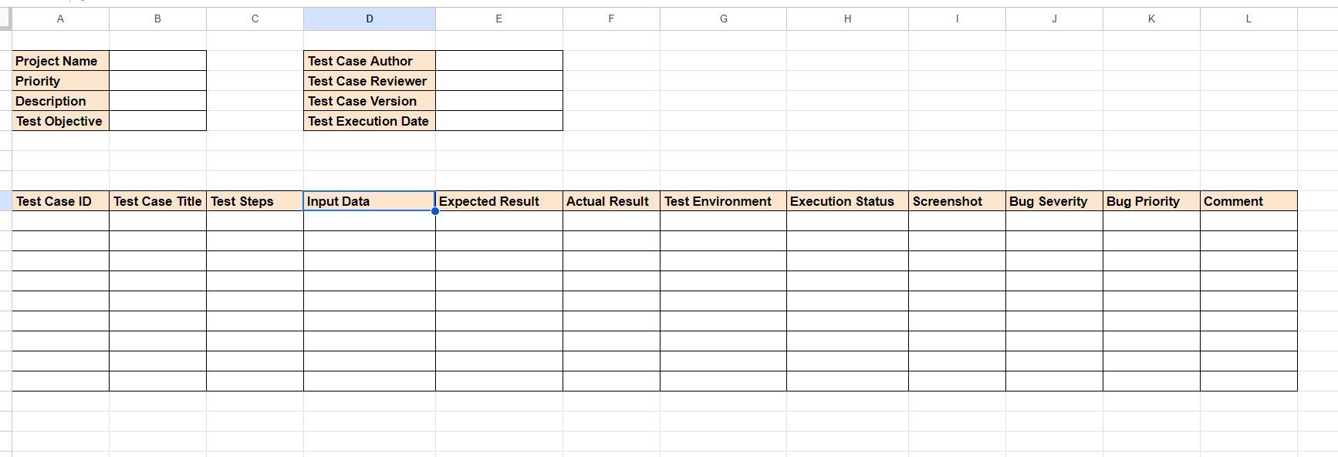

For Security Template Format:

